## Stage 8: *Never Forget IV*

|  |  |
| --- | --- |
| **Bay 7 - ESSTAC** | **Designer: PB Team**  **Rules: USPSA Competition Rules, Current Edition** |

|  |  |
| --- | --- |
| **Scoring: Comstock / LC**  **Rnds/Pts: 33 / 165** | 13 USPSA paper targets, best 2 hits each, and 7 steel, K/D = 1 “A” |

|  |  |
| --- | --- |
| **Procedurals & R.O. Notes** | Standard procedural penalties apply. |

|  |  |
| --- | --- |
| **Starting Position** | Standing anywhere in shooting areas facing downrange.  HANDGUN: Loaded and holstered, wrist below belt.  PCC: Loaded, stock touching belt, both hands on rifle, muzzle downrange, safety on. |

|  |  |
| --- | --- |
| **Start Signal: Audible** | **Stop Signal: Last shot fired** |

|  |  |
| --- | --- |
| **STAGE PROCEDURE** | On audible start signal, engage targets from within shooting area as defined by walls, fault lines, and platform. Platform is part of the shooting area. |

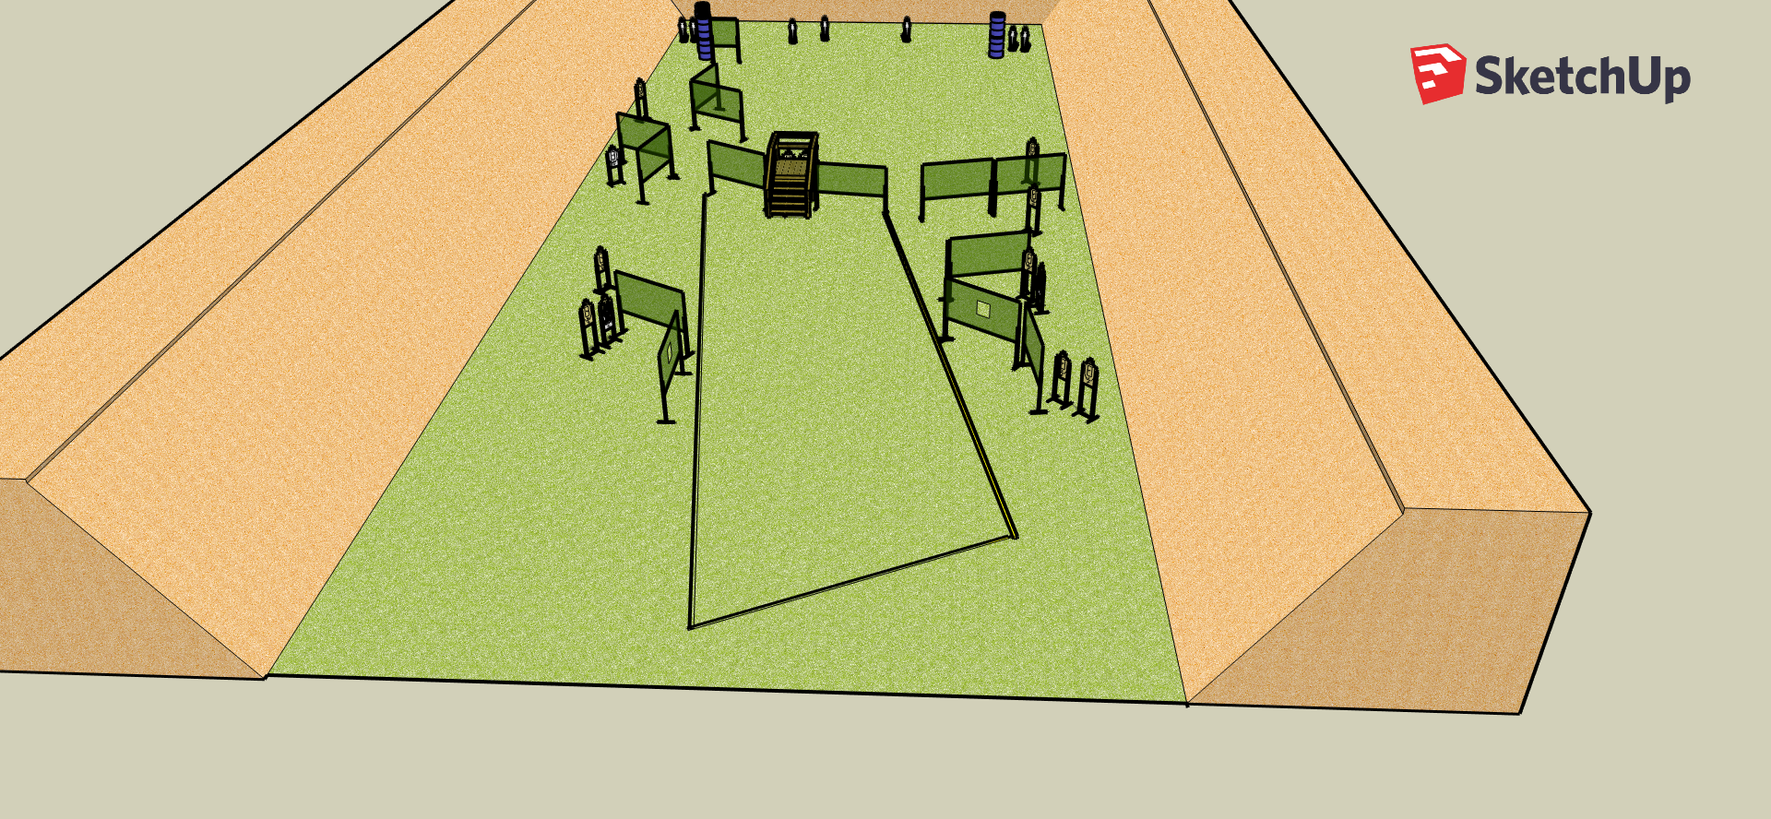

**B**

**A**

**A**